Daily Schedule

9:00 am
Warm Ups
Footwork
Footwork Games

9:45 am
Basics with Equipment
Bladework Practice
Balance Games

11:00 am
Equipment Repair Lessons
Mental Training
Fencing Games
Fencing Rules Class

11:30 am
Bouting

12:00 pm
Pick-up

Foil, Epee, and Saber
Our primary weapon for camp will be the foil, but children will also get to fence saber and epee.

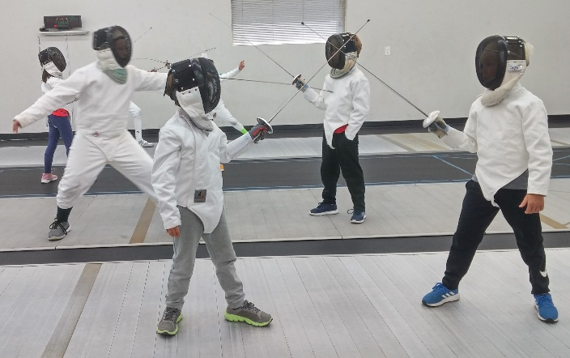
Instructor – Judy O’Donnell


Judy has a Masters of Education from Harvard University and has been coaching fencing for 25+ years. She previously taught at the Boston Fencing Club before moving to Iowa. Judy competed internationally and has sent students to some of the highest levels of competition. She holds a Coaching Authorization from the State of Iowa Board of Educational Examiners.
Judy is occasionally assisted by some of her most advanced students.

Other Programs
The Iowa City Fencing Center offers group classes for children (ages 5 & up), teens, adults, and seniors, as well as private lessons. Our popular birthday parties and special events for groups include learning the basics of fencing from on guard to the fun of fencing real bouts.

Benefits of Fencing
Fencing is a great form of exercise that speeds up reaction times, increases focus and coordination, and practices fast-paced problem-solving skills.

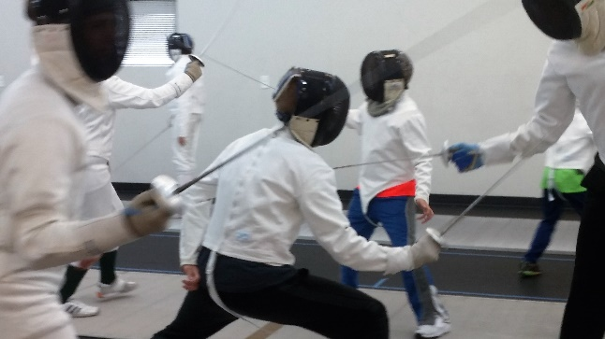
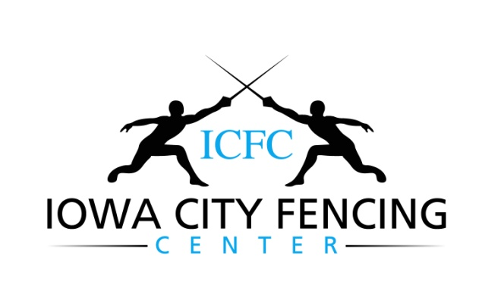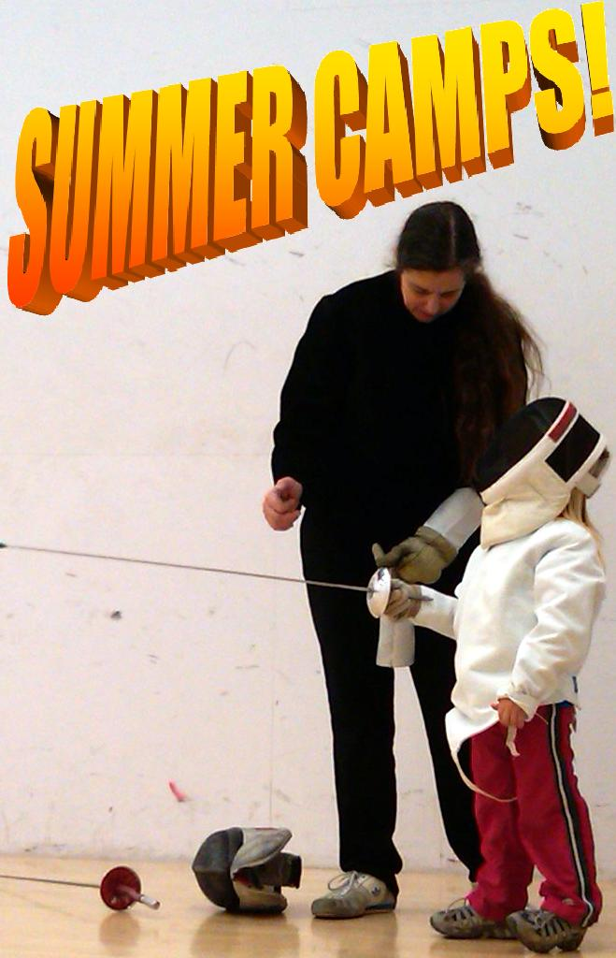

www.iowacityfencingcenter.com
icfencingcenter@gmail.com
415 Highland Ave, Suite 200
Iowa City, IA 52240
(319)-338-7171

Registration

Camps are for children ages 8-14.

Registration forms can be picked up at the Iowa City Fencing Center, downloaded from our website, or mailed directly to you. For a mailed copy call (319)-338-7171.

Class size is limited so be sure to register early!

Return registrations to:
Iowa City Fencing Center
415 Highland Ave, Suite 200
Iowa City, IA 52240

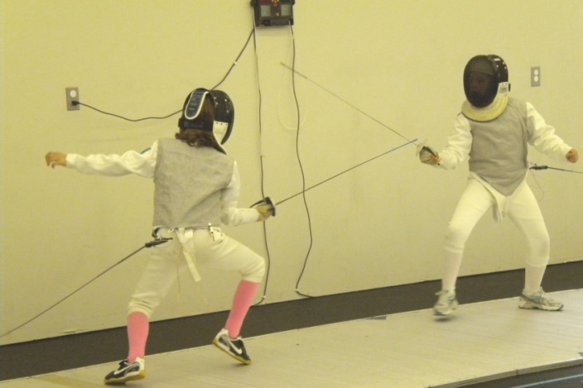

Cancellation Policy
Refunds (excluding $50 registration fee) will be made if cancellation notification is received at least two weeks prior to the start of the session. ICFC reserves the right to cancel a session due to insufficient registration, with full refunds.

Our Facility is Air-Conditioned!

Summer Camp Program

Campers will have an action-packed week learning the skills of competitive fencing while making new friends. It’s fun, fast, and exciting!

We play fun fencing games that incorporate learned fencing movements and other important skills.

Students learn equipment care, fencing rules, and simple mental training techniques.

Campers will have a small tournament on Friday morning. Parents are encouraged to come watch.

Cost: $250
Includes an ICFC t-shirt, water bottle, fencing equipment use, and a $50.00 non-refundable registration fee. Please make checks payable to ICFC and include them with the registration forms.

We are dedicated to creating a fun and exciting atmosphere for competitive and recreational fencers alike!

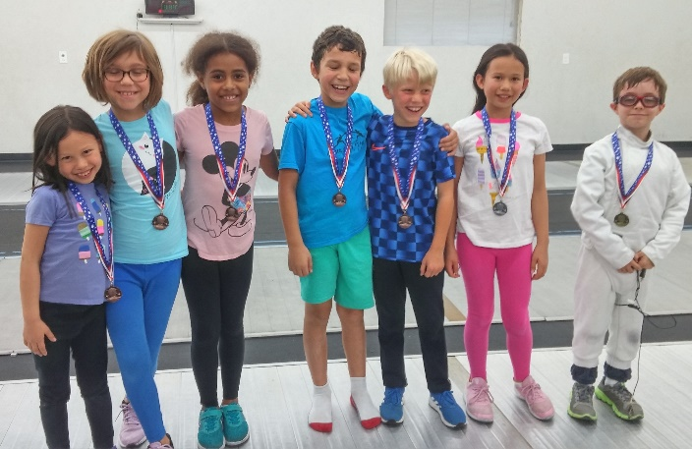

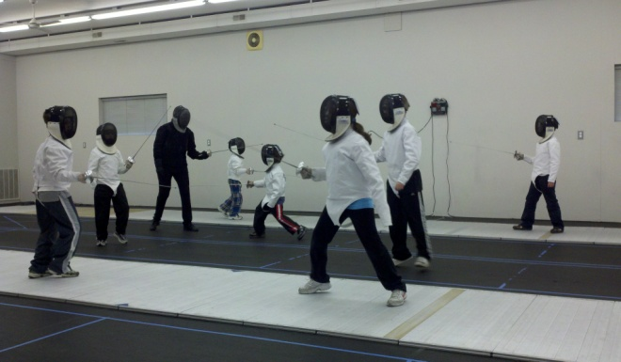

Some FAQ’s
Q: Is it safe?
A: Fencing is one of the safest Olympic sports. Our equipment meets USA Fencing safety standards and is meticulously inspected for safety by our staff. ICFC instructors are CPR and First Aid certified.

Q: Do I have to buy equipment?
A: Not at all. The ICFC provides campers with everything needed to learn how to fence. We do sell equipment if you prefer to have your own. Campers MUST wear athletic shoes and long pants. Absolutely NO sandals, crocs, or shorts.

Summer 2026 Sessions

June 15th-19th (advanced only)
July 20th-24th (all levels)
August 3rd–7th (all levels)

